CST 352 – Assignment 1
Wilsonville, Spring 2020

Create a simple producer/consumer multi-threaded application using ONE of the following:
- .NET System.Threading with C# on Windows.
- UNIX pthreads with C++ on UNIX (extra credit)
- Win32 Threads with C++ on Windows (extra credit)

Implement a thread-safe ring buffer queue class called SafeRing as follows:
- Integer capacity, passed in constructor
- Array of integers for the buffer
- Method Remove() that…
  - Is thread safe: calling thread blocks until it is safe to remove
  - Blocks calling thread until at least one item is in the queue
  - Prints “Removed X”, where X is the number removed
  - Signals any threads waiting to insert to indicate capacity available
- Method Insert() that…
  - Is thread safe: calling thread blocks until it is safe to insert
  - Blocks calling thread until there is space for at least one item in queue
  - Prints “Inserted Y”, where Y is the number inserted
  - Signals any threads waiting to remove to indicate item available
- Method Count() that…
  - Is thread safe: calling thread blocks while any insert/remove completes
  - Returns the current number of items in the queue

Implement a class called Producer as follows:
- Given a SafeRing queue reference in it’s constructor
- Given a total number of items to produce
- Method Start() that starts “producing” on a thread
- Produces by…
  - Randomly generating integer between 1 and 1000
  - Inserting number into the queue
  - Sleeping the thread for that number of msec
- When the total number of items are produced…
  - Exits the thread
  - Signals complete
- Accessor Complete returns a syncrhonization object signaled when complete

Implement a class called Consumer as follows:
- Given a SafeRing queue reference in it’s constructor
- Method Start() that starts “consuming” on a thread
- Consumes by…
  - Removing an integer from the queue
  - Randomly generating a second integer between 1 and 1000
  - Sleeping the thread for the second number of msec
- Method Stop() that signals consuming thread to stop immediately if waiting for an item, or after consuming current item

Implement a Main() as follows:
- Instantiates a SafeRing queue with capacity of 5
- Instantiates and starts 2 producers, each to produce 10 items
- Instantiates and starts 2 consumers
- Wait for all producers to complete then signal consumers to stop

Extra Credit:
- Add timeouts to SafeRing Insert() and Remove() methods:
  - Throw a TimeoutException if cannot acquire lock after specified number of msec
  - Throw a TimeoutException if no items available, or no room available within the specified number of msec
- Add timeouts to Producer and Consumer classes:
  - Pass timeout to queue’s Insert() and Remove()
  - Gracefully handle TimeoutExceptions: should not exit thread
- Use a timeout of 10 msec for all producers and consumers
- Warning: watch out for leaving Mutex’s locked when throwing exceptions!

Turn in your source code on Blackboard in a zip file called CST352_Assign1_your_name.zip (e.g. “CST352_Assign1_Pete_Myers.zip”. The instructor should be able to compile, run and verify your program. This means you need to include your Solution/Project or Makefile as appropriate.

Extented Exercise
The following is an exercise as an extension to assignment 1. It is not graded, but just provided as an opportunity to learn more about multi-threading. Note that this assumes you have implemented the extra credit timeouts. If not, then ignore the timeout, warning and error counters below. Instead, just use the produced and consumed counters.

Often its challenging to know how to “tune” a multi-threaded application. That is, how many threads to use for a task, how much capacity to allocate to a queue, etc. You can use performance monitoring to gain insight, and then use that to guide your choices.

On Windows, the Performance Monitor application can show a huge variety of counters for a Windows machine. Available counters include system data and application data.

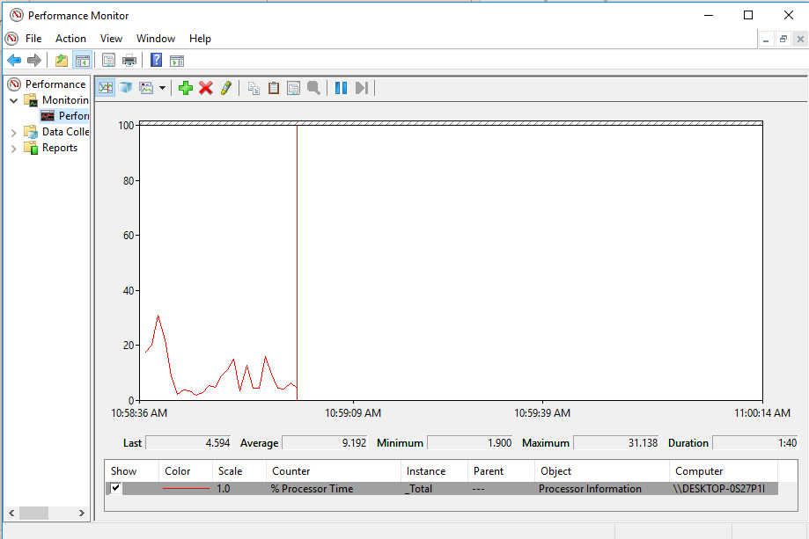

The following pages describe how to add custom counters to your Assignment 1 application and how to use the Performance Monitor to view the data in realtime.

Step 1: Create performance counters

- Add a new command line application project, “SetupPerformanceCounters”, to your Assignment 1 solution
- Open the new Program.cs file
- Add using System.Diagnostics;
- Add the following code to the Main() method:

if (PerformanceCounterCategory.Exists("CST352"))
{
PerformanceCounterCategory.Delete("CST352");
}
CounterCreationDataCollection counterCollection =
new CounterCreationDataCollection();
counterCollection.Add(new CounterCreationData("TimeoutRate", "TimeoutRate",
PerformanceCounterType.RateOfCountsPerSecond32));
counterCollection.Add(new CounterCreationData("WarningRate", "WarningRate",
PerformanceCounterType.RateOfCountsPerSecond32));
counterCollection.Add(new CounterCreationData("ErrorRate", "ErrorRate",
PerformanceCounterType.RateOfCountsPerSecond32));
counterCollection.Add(new CounterCreationData("ProducedRate", "ProducedRate",
PerformanceCounterType.RateOfCountsPerSecond32));
counterCollection.Add(new CounterCreationData("ConsumedRate", "ConsumedRate",
PerformanceCounterType.RateOfCountsPerSecond32));
PerformanceCounterCategory.Create("CST352", "CST352",
PerformanceCounterCategoryType.SingleInstance, counterCollection);

- Build your solutions
- Navigate to the new SetupPerformanceCounters.exe file in File Explorer, right click and choose “Runs as administrator”

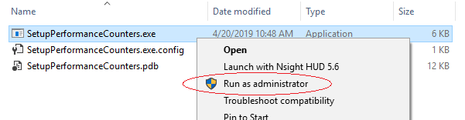

The new performance counters will now be available for use in Performance Monitor.

Step 2: Run Performance Monitor and add performance counters

- Start the Performance Monitor from the Windows start bar…


- Select the “Performance Monitor” item in the tree on the left…
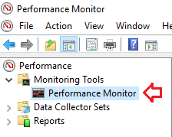

- Click the + sign to add new counters to the view…
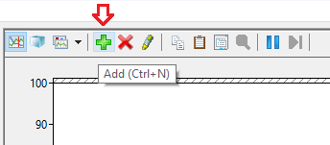

- Scroll down to the CST352 item in the list and expand it…
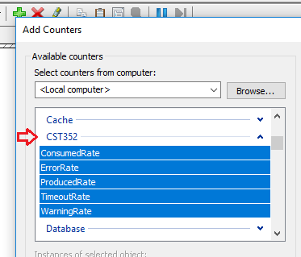

- Click “Add” and then “OK”

You will now see the counters in the monitoring view. No data appear will appear yet.

Step 3: Add data to the counters in your application

- Open Program.cs in your Assignment 1 project
- Add using System.Diagnostics;
- Initialize the performance counters by adding the following code to the top of your Main() method:

PerformanceCounter timeoutRateCounter =
new PerformanceCounter("CST352", "TimeoutRate", false);
PerformanceCounter warningRateCounter =
new PerformanceCounter("CST352", "WarningRate", false);
PerformanceCounter errorRateCounter =
new PerformanceCounter("CST352", "ErrorRate", false);
PerformanceCounter producedRate =
new PerformanceCounter("CST352", "ProducedRate", false);
PerformanceCounter consumedRate =
new PerformanceCounter("CST352", "ConsumedRate", false);
timeoutRateCounter.RawValue = 0;
warningRateCounter.RawValue = 0;
errorRateCounter.RawValue = 0;
producedRate.RawValue = 0;
consumedRate.RawValue = 0;

- Open SafeRing.cs
- Add using System.Diagnostics;
- Add the timeoutRateCounter to the member variables

private PerformanceCounter timeoutRateCounter;

- Initialize the counter in the constructor

timeoutRateCounter=new PerformanceCounter("CST352", "TimeoutRate", false);

- Increment the counter when a timeout occurs in Add() and Remove()

if (!WaitHandle.WaitAll(new WaitHandle[] { mutex, hasCapacity }, timeout))
{
timeoutRateCounter.Increment();
throw new TimeoutException("Insert timed out!");
}

…and…

if (!WaitHandle.WaitAll(new WaitHandle[] { mutex, hasItems }, timeout))
{
timeoutRateCounter.Increment();
throw new TimeoutException("Insert timed out!");
}
- Open Producer.cs
- Add using System.Diagnostics;
- Add the following counters to the member variables…

private PerformanceCounter warningRateCounter;
private PerformanceCounter errorRateCounter;
private PerformanceCounter producedRate;

- Initialize the counters in the constructor…

warningRateCounter = new PerformanceCounter("CST352", "WarningRate", false);
errorRateCounter = new PerformanceCounter("CST352", "ErrorRate", false);
producedRate = new PerformanceCounter("CST352", "ProducedRate", false);

- Increment the warning counter when a timeout occurs, before giving up…

producer.warningRateCounter.Increment();

- Increment the error counter when giving up…

producer.errorRateCounter.Increment();

- Increment the produced counter after successfully producing…

producer.producedRate.Increment();

- Open Consumer.cs
- Add using System.Diagnostics;
- Add the following counters to the member variables…

private PerformanceCounter warningRateCounter;
private PerformanceCounter consumedRate;

- Initialize the counters in the constructor…

warningRateCounter = new PerformanceCounter("CST352", "WarningRate", false);
consumedRate = new PerformanceCounter("CST352", "ConsumedRate", false);

- Increment the warning counter when a timeout occurs, before giving up…

consumer.warningRateCounter.Increment();

- Increment the produced counter after successfully producing…

consumer.consumedRate.Increment();

- Build your solution

Step 4: Monitor and tune!

- Run your application and observe the Performance Monitor window
- You should see data appear in the window. It may be difficult to see.
- Adjust the color and scale for any of the counters by double-clicking on the counter in the list below the graph

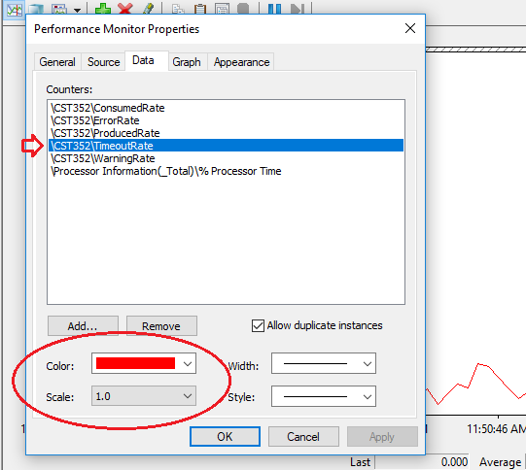

- Run your application again and continue adjusting the view until you can clearly see what is happening
- Choose different # producers, # consumers, queue capacity and timeout. Run and analyze the performance. Rinse and repeat.

This is called tuning! Which values produce the best performance?
Specifically, how do you get the following:

Highest rates of produced and consumed
Lowest rates of timeouts and warnings
No errors at all

